**2025 Bob Wade**

**Memorial Masters**

**2025 Hilton Bennett**

**Memorial Masters**

**2025 MGCF Challengers**

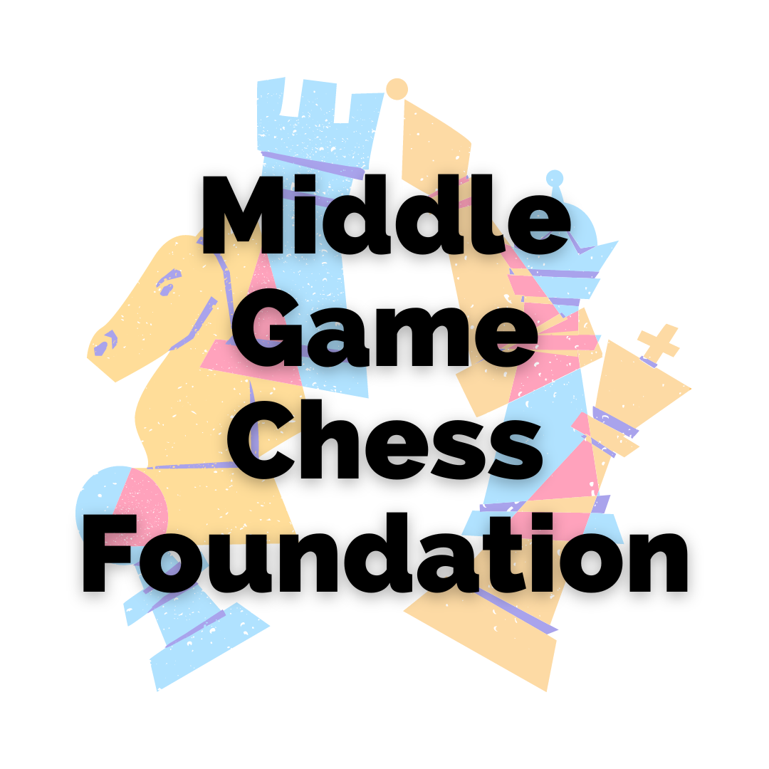 

**Dates:**

Monday, January 13 – Sunday, January 19, 2025

**Format:**

Three round robin 10 player events. The Bob Wade Memorial Masters will be an IM norm event with invited GM’s, IM’s and FM’s. The Hilton Bennett Memorial Masters is open to players with FIDE elo ratings of 1800 or higher. The Middle Game Chess Foundation Challengers is open to players with FIDE elo ratings below 1800, with preference being given to junior players under 20 years old.

**Rating:**

All events will be NZCF and FIDE rated where possible.

**Entry Fees:**

The Bob Wade Memorial Masters is entry by invitation.

Entry fee for the Hilton Bennett Memorial Masters and Middle Game Chess Foundation Challengers events is $150.

Fees are payable to: Howick Chess Centre Account: BNZ, Howick **02-0168-0020937-000**

**Arbiters:**

IA Ying Wang & NA Richie Christie

**Time Control:**

90 minutes + 30 seconds increment from move one.

**Venue:**

Carbine Room, Waipuna Hotel & Conference Centre, 58 Waipuna Road, Mt. Wellington, AUCKLAND.

**Sponsors:**

These tournaments are part of the sponsorship program of the MGCF [Middle Game Chess Foundation] and are also financially assisted by the FIDE Planning & Development Commission. We acknowledge the support of the FIDE PDC in allowing these tournaments to take place.

**Accommodation:**

Accommodation can be booked directly at Waipuna Hotel & Conference Centre at a discounted rate using the code NZCF0125. You can also contact the Waipuna Hotel bookings manager Shabnam Khurana at [ShabnamK@waipunahotel.co.nz](mailto:ShabnamK@waipuna.co.nz) for assistance.

**Timetable:**

**Monday, January 13**

Opening & Players Meeting: 3.00 pm

Round 1: 4.00 pm

**Tuesday, January 14**

Round 2: 10.30 am Round 3: 4.00 pm

**Wednesday, January 15**

Round 4: 4.00 pm

**Thursday, January 16**

Round 5: 4.00 pm

**Friday, January 17**

Round 6: 10.30 am Round 7: 4.00 pm

**Saturday, January 18**

Round 8: 4.00 pm

**Sunday, January 19**

Round 9: 10.30 am

**Prizegiving will be held at approximately 3.00 pm for the Hilton Bennett Memorial & MGCF sections and participants in the Bob Wade Memorial Masters section are invited to attend the Middle Game Chess Foundation dinner & prizegiving at Wellington’s restaurant at Waipuna Hotel at 6.00 pm.**

**Prizes:** (in NZ $)

**MGCF Challengers: 1st $400; 2nd $300; 3rd $200; 4th $100**

**Hilton Bennett Memorial: 1st $400; 2nd $300; 3rd $200; 4th $100**

**Bob Wade Memorial: 1st $2,000; 2nd $1,500; 3rd $1,000; 4th $750; 5th $500**

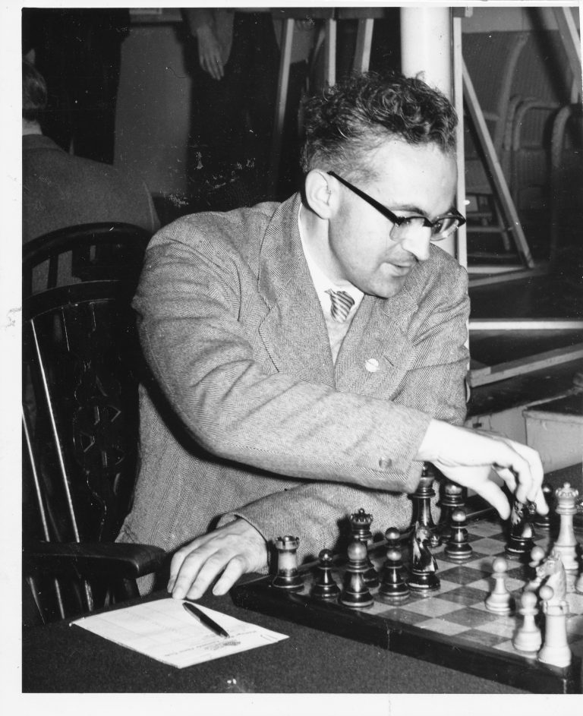

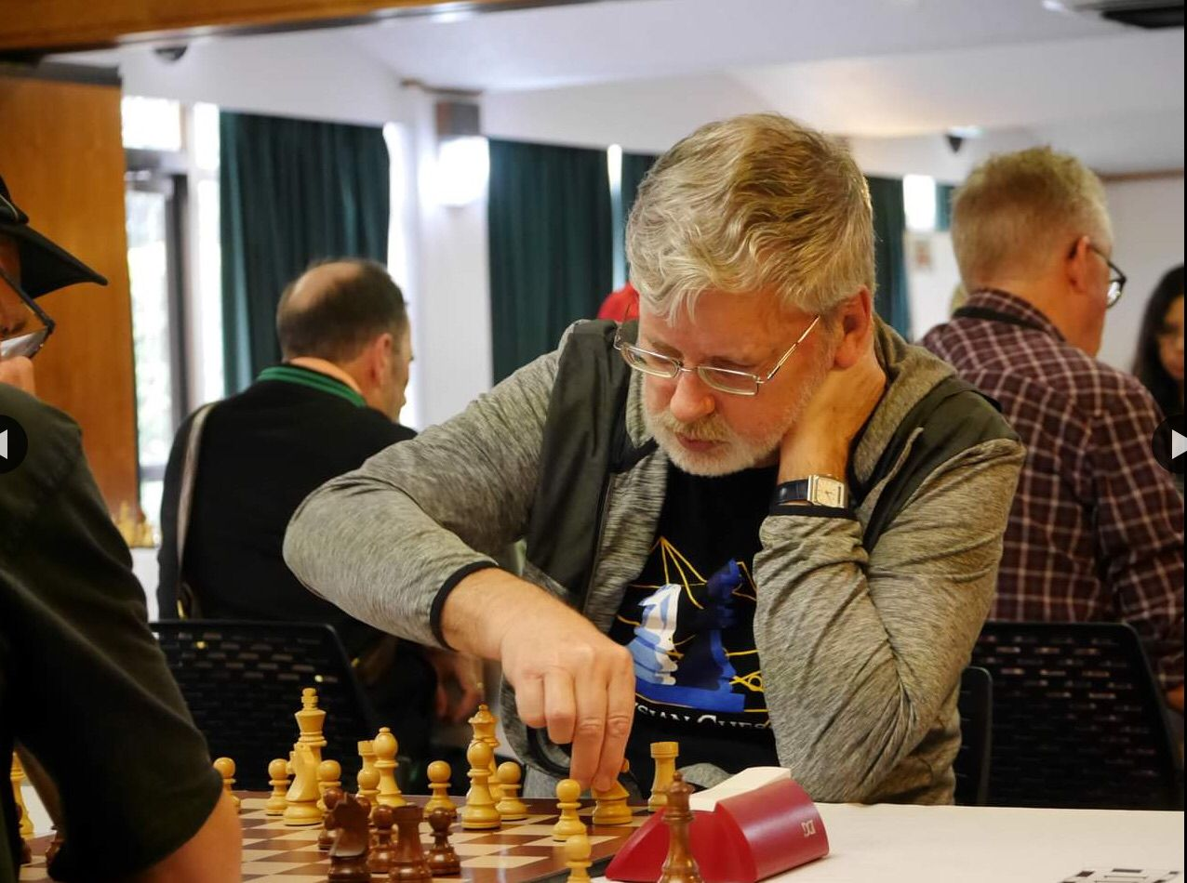

**IM Bob Wade CM Hilton Bennett**

**Chief Organiser:** Paul Spiller

[paulsspiller@outlook.com](mailto:paulsspiller@outlook.com)

Ph: +64 274595176